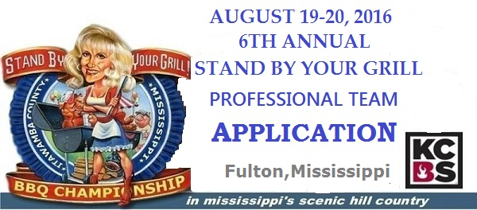
- Over $10,000 in CASH Prizes
- KCBS rules apply(go to www.kcbs.us for more info
- Free Ancillary participation
- Cash Awards through 10th place in all sanctioned categories
- Cash Prizes for Ancillary
- 100% KCBS Certified Judges for sanctioned categories
- Qualified State Championship
- American Royal Invitational Contest Qualifier
- Jack Daniel’s World Championship Invitational Barbecue Qualifier
Team Name: ___________________________________
Team Captain:__________________________________
Address:___________________________________________
City: _________________________________ State:_____________ Zip:_____________
Phone:____________________ Cell___________________
E-mail address: ___________________________ KCBS#_______________________
$ _______ T-Shirt Total

$ ________ Grand Total

Professional Contest (must compete in all 4 categories of Chicken  Pork Ribs, Pork and Beef Brisket). This ALL-INCLUSIVE professional  entry includes a concrete pad campsite with an additional cooking  area in the scenic Whitten Historical Center Campground on the  Tennessee-Tombigbee Waterway, equipped with both 30 and 40  amp electrical connections and every campsite has a water  hook-up. | $275.00
Late fee for registration postmarked or returned after June 14, 2016 | $25.00

Order a Stand By Your Grill T-Shirt: $15.00 each (Mark with the number for each size)
_____ Small _____Medium _____ Large _____ XL _____ 2X ______ 3X ______ 4X _______ 5X
Number of Shirts x $15.00 =____________

I wish to participate in the Dean’s Sausage Ancillary Contest ______Yes _______ No

NO REFUNDS GIVEN ON OR AFTER AUGUST 1, 2016
ALL REGISTERED TEAMS WILL RECEIVE A PROFESSIONAL COOK'S PACKET CONTAINING DETAILED INFORMATION
ABOUT THE EVENT AND VENUE.
I have read and agree to abide by all the rules and regulations set forth by the Stand By Your Grill BBQ Competition.
Waiver of Liability
I understand and acknowledge that participation in this event can be hazardous, and I hereby assume all risk while participating. I, and anyone entitled to act on my behalf, waive and release the Stand By Your Grill BBQ Competition, The Itawamba County Development Council and the City of Fulton, its agents, employees, officers, officials and sponsors from all rights and claims for any personal injury, death, or property damage suffered by me, or that I cause to others, as a result of my participation in this event. I, the undersigned, agree, without any right of payment or editing, to allow the Stand By Your Grill BBQ Competition and The Itawamba County Development Council to use the images of me and/or my children, including reproduction of photos, video, audio or other reproductions, for use in all types of media for public relations purposes to promote the event.

Signature of Team Captain (required): __________________________________________ Date: _____________________________

Submit completed Entry Form along with a check payable to “The Itawamba County Development Council” to:

The Itawamba County Development Council Telephone: 662-862-4571
Attn: Vaunita Martin Email: vmartin@itawamba.com
PO Box 577
Fulton, MS 38843

